**Create and Deploy ARM Template – Visual Studio Code**

**Step 1:** Download Visual Studio Code from below link:

<https://code.visualstudio.com/>

Click on **Download for Windows**. Note: if you are using other OS click on other platforms

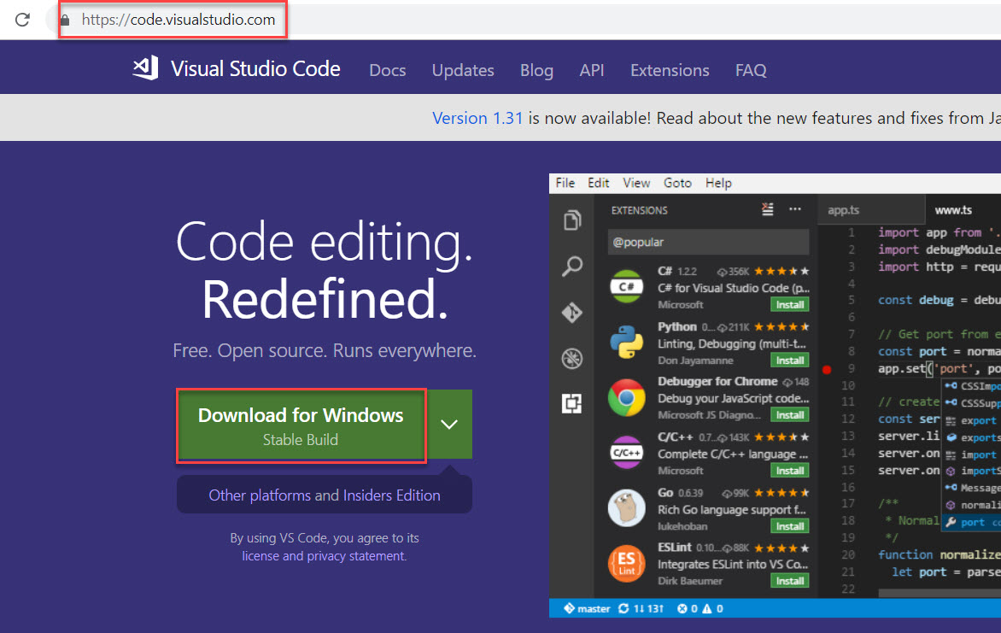

**Step 2:** Download Sample Template from below link:

<https://cgimaterialstorage.blob.core.windows.net/labs/201-web-app-sql-database-server.zip>

This ARM template Deploy Web App, SQL Server, SQL Database.

**Step 3:** Start **Visual Studio Code**.

**File -> Open Folder…**

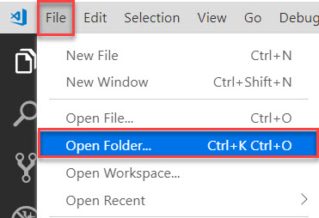

Browse that folder

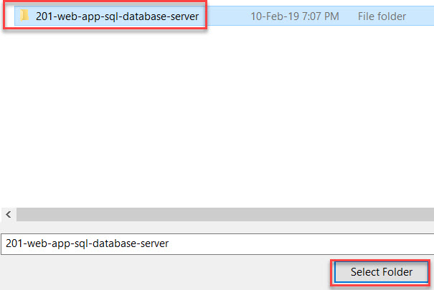

**Step 4:** Select **azuredeploy.json** file

Modify if you wish.

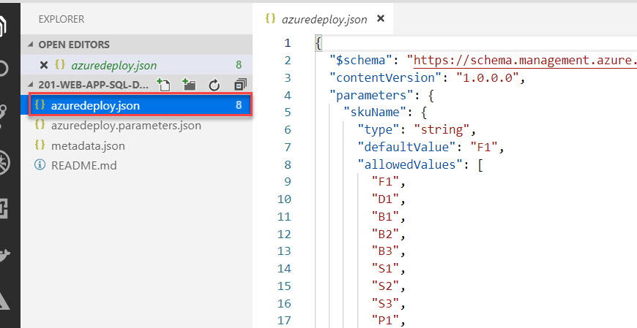

**Step 5:** Click on **View** menu -> **Terminal**

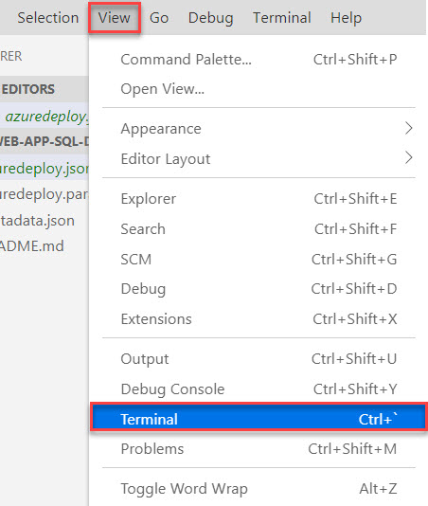

**Step 6:** Now time to Deploy ARM Template on Azure

First Login with Azure Account

Login-AzureRmAccount

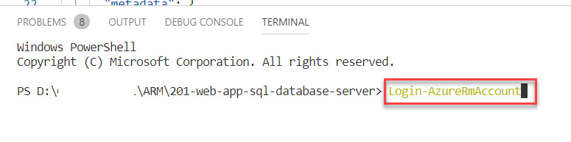

Enter Microsoft Azure Credentials

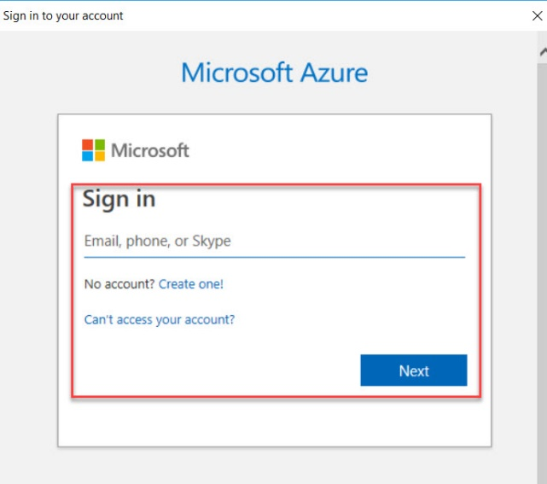

It will Load Azure Subscription

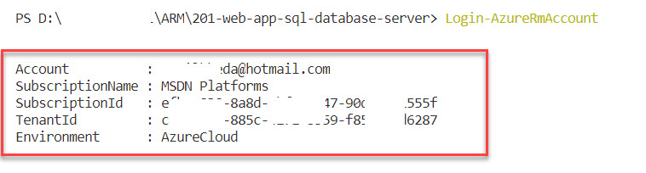

If you have multiple subscription follow below step otherwise skip it.

Get-AzureRmSubscription

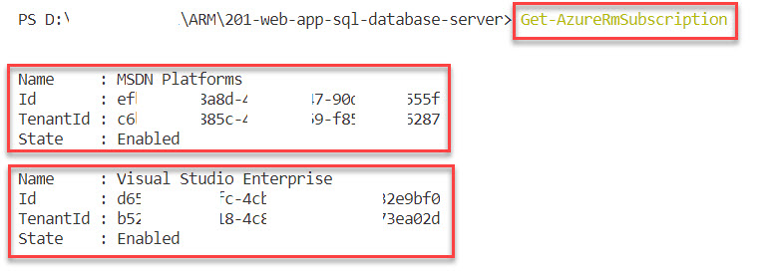

Select-AzureRmSubscription -SubscriptionId "subscription-id"

Ex. Select-AzureRmSubscription -SubscriptionId "e65e5246c-84fc-4323-8a1e-723g3323sbf0"

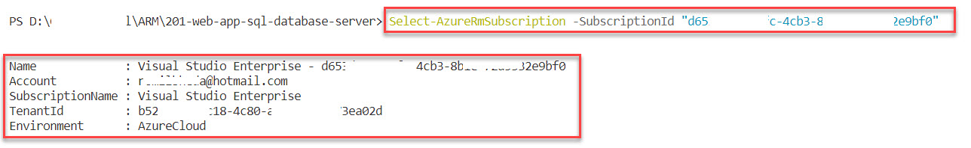

**Step 7:** Create New Resource Group

New-AzureRmResourceGroup -Name ARMVSCodeRG -Location "Southeast Asia"

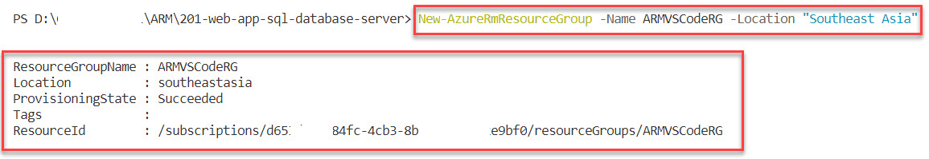

**Step 8:** Create New Deployment

New-AzureRmResourceGroupDeployment -Name ARMVSCodeDeployment -ResourceGroupName ARMVSCodeRG -TemplateFile azuredeploy.json

Wait for couple of minutes to deploy Web App, SQL Server, SQL Database on Azure

